BIOGRAPHY – KYLE WHITE
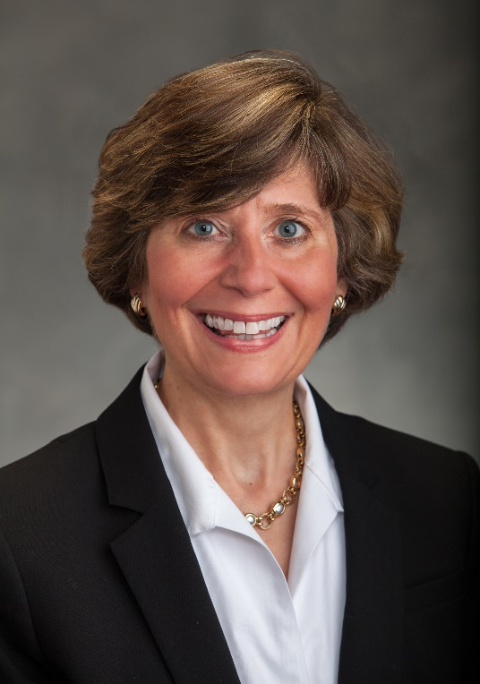

Kyle White is an Area Leader (Medina, Summit and Lorain Counties) and Community Development Educator (Lorain and Medina Counties) for Ohio State University Extension. She specializes in Leadership Development as well as Community and Youth Development. Her career spans over 30 years mostly in the private sector with 16 years spent in Healthcare marketing and sales. She also has been a consultant for McDonalds Franchise operators, a Trade Marketing Manager in Commercial Children’s Products and she has worked in Higher Education as an Alumni Director at North Central College in Illinois and Stanford University Law School in Palo Alto California. For several years she worked with her husband in his manufacturer’s representative firm where she earned her stripes running a small business.
.
Kyle is drawn to the challenge of learning, research, planning, and executing. Her experience and skills include training, product launches, and managing events. At McDonalds Corp, as a Business Consultant to franchise owners, Kyle gained first-hand knowledge of the business acumen, planning, and work ethic of owners, managers, and staff of those restaurants. During leadership training at Hamburger University in Oakbrook Illinois, Kyle was awarded the Gold Hat Award for Leadership by her classmates. This honor is bestowed on one class member who personifies qualities of Leadership and Teamwork. She is a certified Strengths Finders Coach and her top five strengths are Futuristic, Strategic, Developer, Input and Empathy.

Kyle is a native of northeast Ohio where she has lived most of her life. Her career took her to Chicago Illinois and San Francisco California before returning to Medina County in 1986. She has been active in her church and been an active community volunteer over the last 30 years. She chaired the Medina County Human Resource Council and participated on the Public Relations Committee for the Medina Chamber of Commerce. She was the United Way Day of Caring Chair and a Board Member of the Board of the United Way of Medina County. She has also been on the board of the Medina County Drug Abuse Commission (MCDAC) and currently serves on the boards of Healing Hoofs, the Center for Food Innovation Oberlin and the Medina County District Library Board. In 2020 she was honored with a nomination for the Excellence in Education Leadership Award for Leadership Medina County.

