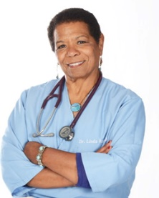
Linda Randall, DVM began her career after Ohio State University working with companion animals in a practice that was primarily dairy cattle. She then built Cloverleaf Animal Hospital, in Westfield Center, OH, gaining extensive experience as a Board Certified Specialist in Companion Animals, while also establishing herself as a respected dog trainer. Using the science of positive reinforcement, Linda is setting a new standard for how to raise, engage and work with animals. Her commitment to understanding how behavior works from medical and emotional aspects, and geeking out on current learning research is changing the way people handle and perceive their pets and livestock. As the owner of One Smart Dog in Seville, she specializes in helping people access their dog’s best self through non-aversive learning, training and instructing. Dr. Randall is widely known for her love of teaching people how to reach their dog’s inner best self, Lindy Hopping wherever she goes, and her conviction that compassion, generosity and a gentle sense of humor will always return to the giver tenfold. She is also determined to learn to play the ukulele.

Contact:
1smartdog.LR@gmail.com 330.958.9224 https://www.facebook.com/linda.randall.505

